Change is coming!

The Box Tops for Education program is changing the way we can earn cash for our school! Over the summer, participating brands have begun to change their packaging from the traditional Box Tops clips to the new Box Tops label. THE OLD

BOX TOPS CLIPS
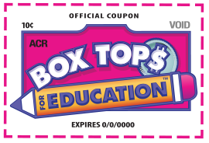
Traditional Box Tops clips are being phased out of production, but may continue to be found on many products throughout the store. You can still clip them and send them to school. Every valid Box Tops clip is worth 10¢ for your school. Make sure each one has a clearly visible product acronym and expiration date.

THE NEW

BOX TOPS LABELS
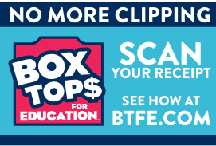
Eventually the Box Tops program will become digital-only. Participating brands are starting to change their packaging from a traditional Box Tops clip to the new Box Tops label. If you see this label, use the new Box Tops app to scan your receipt. Box Tops are still worth 10¢ for your school. The app will find participating products purchased at any store and instantly add cash to your school’s earnings online.

Moving forward, instead of clipping from packages and checking expiration dates, all Box Tops will be earned digitally by scanning your receipt. The Box Tops for Education team has worked hard to build a NEW-and-improved, user-friendly Box Tops mobile app, available now. The new app allows you to scan your store receipt and instantly add Box Tops to our school’s earnings online.

Here’s how it works:

Step 1: Download the new app or update your existing app

Step 2: Buy Box Tops Products

Step 3: Scan Your Receipt

Step 4: Earn Cash for our school!

If you shop online:

Forward your email receipt to receipts@boxtops4education.comusing the same email that's associated with your Box Tops For Education account

